Lyceum Kennedy Uniform Guide
Lyceum Kennedy has two types of uniforms: Regular and Physical Education (PE). Uniforms are to be worn depending on the schedule for each class. Each division of our school has a specific uniform that must be worn.

Preschool -- Nursery, Pre-Kindergarten, and Kindergarten
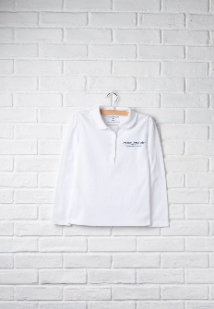
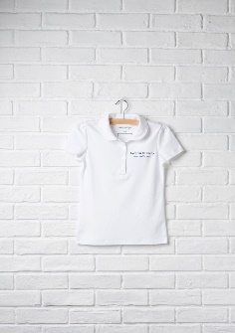
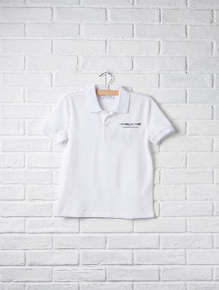
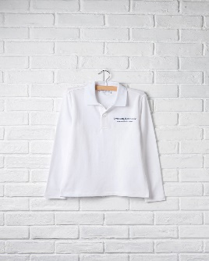
Tops: Polo shirt (Long or Short Sleeve) or Peter Pan Polo Shirt (Long or Short Sleeve) – white with school logo

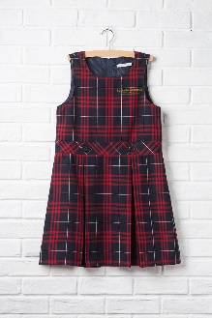
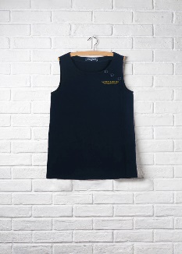
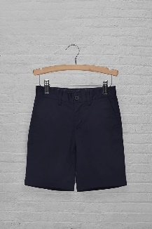
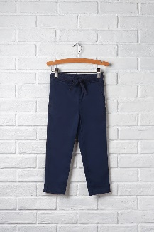
Bottoms: Navy Blue Pull-on Pant, Navy Blue Short, Neoprene Pinafore with school logo or Plaid Pinafore school logo

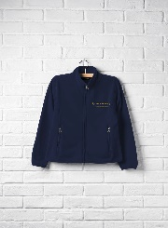
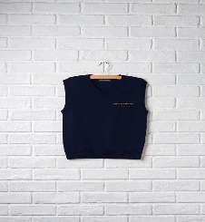
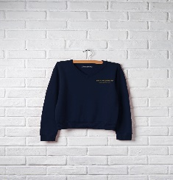
Sweaters/Jackets: Navy Long Sleeve V-Neck Sweater, Navy V-Neck Vest Sweater or Navy Full-Zip Fleece Jacket with school logo

Gym (PE) Class: No uniform is required. Sneakers only!

Lower School – 1st to 5th Grade
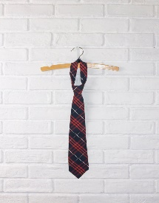
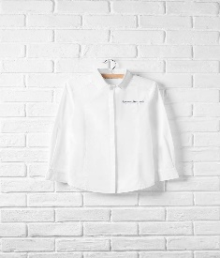
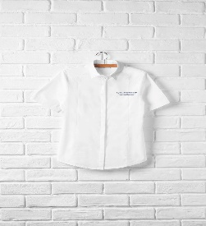
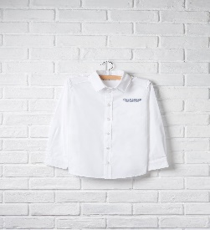
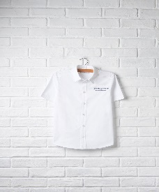
Tops: Unisex Button Front Shirt (Long or Short Sleeve) or Feminine Button-Front Shirt (Long or Short Sleeve) – white with school logo, Tie

Bottoms: Navy Blue Pant (Unisex or Feminine Slim Cut), Navy Blue Short, Plaid Skirt, Neoprene Pinafore with school logo or Plaid Pinafore school logo
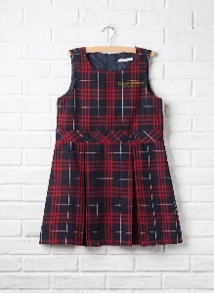
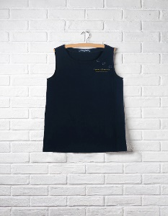
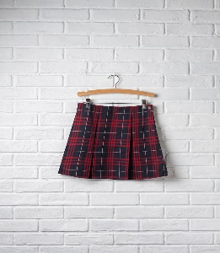
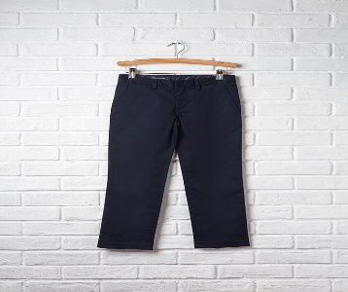

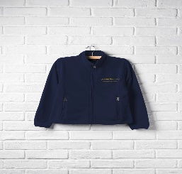
Sweaters/Jackets: Navy Long Sleeve V-Neck Sweater, Navy V-Neck Vest Sweater or Navy Full-Zip Fleece Jacket with school logo

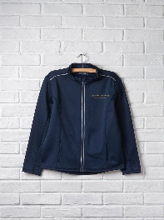
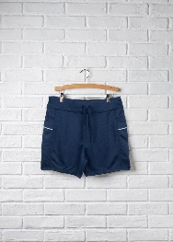
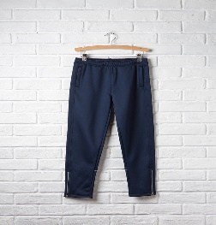
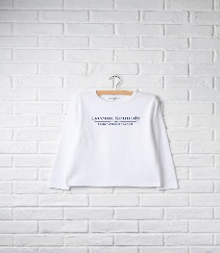
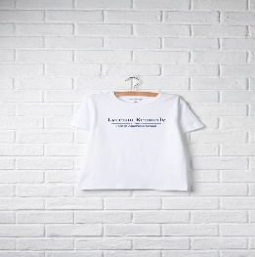
Gym Uniform (Only to be worn on gym days): White Tee (Short or Long Sleeve), Pull-on Track Pants, or Pull-on Track Shorts, and Zip-Front Track Jacket

Middle and Upper School -- 6th to 12th Grade
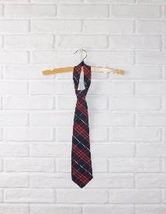
Tops: Unisex Button Front Shirt (Long or Short Sleeve) or Feminine Button-Front Shirt (Long or Short Sleeve) – white with school logo

Bottoms: Navy Blue Pant (Unisex or Feminine Slim Cut), Navy Blue Short, Plaid Skirt, Neoprene Pinafore with school logo or Plaid Pinafore school logo

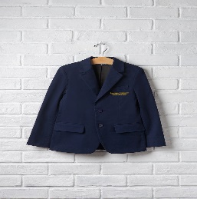
Sweaters/Jackets: Navy Long Sleeve V-Neck Sweater, Navy V-Neck Vest Sweater, Navy Full-Zip Fleece Jacket with school logo, or Navy Blazer with logo

Gym Uniform (Only to be worn on gym days): White Tee (Short or Long Sleeve), Pull-on Track Pants, or Pull-on Track Shorts, and Zip-Front Track Jacket

Dos and Don’ts For All Divisions
Dos:
- Do wear one of the uniform options for your division
  - Navy blue pants
  - Navy blue shorts
  - Jumper
  - Skirt
  - White Shirt with logo
- Do wear navy blue V-neck cardigan sweater or sweater vest with school logo (optional)
- Do wear navy blue zip fleece jacket with school logo (optional)
- Do wear navy or white socks or tights
- Do wear black dress shoes
- Do wear LK gym clothes on gym days
- Do wear sneakers on gym days
- Do wear only navy leggings under skirt or jumper (optional)

Don’ts:
- Don’t wear jeans/Denim, sweatpants or sweat-shorts
- Don’t wear any other shirt that is not part of the Lyceum Kennedy uniform policy
- Don’t wear a vest sweater if you are wearing the jumper
- Don’t wear sneakers unless it is a gym day
- Don’t wear any other shoes, sandals, or boots except black shoes
- Don’t wear bright-colored tights or socks
- Don’t wear skirts that are less than 5inches above the knee
- Don’t wear the LK gym tee shirts on non-gym days
- Don’t wear any shoes other than sneakers on gym days (no black shoes, Uggs, snow boots, rain boots, sandals, etc.)

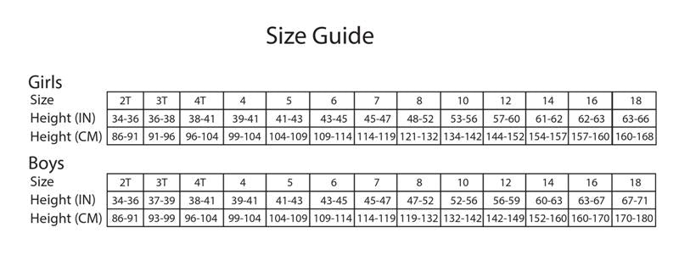
To help you determine your child’s size, please refer to the chart below.

Quick Uniform References Guide
 | Preschool (Nursery, Pre-K, and K) | Lower School (1st to 5th Grade) | Middle/Upper School (6th to 12th)
Unisex Short Sleeve Polo -- White | √
Unisex Long Sleeve Polo -- White | √
Girls Short Sleeve Peter Pan Polo -- white | √
Girl’s Long Sleeve Peter Pan Polo -- White | √
Unisex Long Sleeve Button Front Shirt -- white |  | √ | √
Unisex Short Sleeve Button Front Shirt -- white |  | √ | √
Feminine Short Sleeve Button Front Shirt -- white |  | √ | √
Feminine Long Sleeve Button Front Shirt -- white |  | √ | √
Long Sleeve V-Neck Sweater (Unisex) – Navy Blue | √ | √ | √
Unisex V-Neck Sweater Vest – Navy Blue | √ | √ | √
Full-Zip Fleece Jacket – Navy Blue (Unisex) | √ | √ | √
Unisex Blazer | √ | √ | √
Unisex Straight Leg Pant – Navy Blue |  | √ | √
Feminine Fit Slim Pant – Navy Blue |  | √ | √
Unisex Pull-on Pant –Navy Blue | √
Straight Leg Short – Navy Blue (Unisex) | √ | √
Neoprene Pinafore – Navy Blue | √ | √
Plaid Pinafore | √ | √
Plaid Two Pleat Shirt |  | √ | √
Tie (both) | √ | √ | √
Zip Front Track Jacket |  | √ | √
Unisex Short Sleeve Tee |  | √ | √
Unisex Long Sleeve Tee |  | √ | √
Pull-on Track Short |  | √ | √

